H.T No
Regulations:
A20

Sreenidhi Institute of Science and Technology
(An Autonomous Institution)
Code No: 8AC42 Date: 30-Aug-2023 (FN)

B.Tech I-Year II- Semester External Examination, Aug/Sept-2023 (Supplementary)
ELECTRICAL CIRCUITS AND NETWORKS ANALYSIS (ECE)

Time: 3 Hours Max.Marks:70

Note: a) No additional answer sheets will be provided.
b) All sub-parts of a question must be answered at one place only, otherwise it will not be valued.
c) Missing data can be assumed suitably.
Bloom's Cognitive Levels of Learning (BCLL)

Remember | L1 | Apply | L3 | Evaluate | L5
Understand | L2 | Analyze | L4 | Create | L6

Part - A Max.Marks:20

Answer all QUESTIONS.

 |  | BCLL | CO(s) | Marks
1 | State Ohm’s law. | L1 | CO1 | [2M]
2 | Define Form factor and Peak Factor. | L1 | CO2 | [2M]
3 | Define i) MMF ii) Flux | L1 | CO3 | [2M]
4 | State Norton’s Theorem. | L1 | CO4 | [2M]
5 | Define port and two port network. | L1 | CO5 | [2M]
6 | Explain initial conditions of Capacitor. | L2 | CO6 | [2M]
7 | Draw the volt-current characteristics of practical voltage source. | L1 | CO1 | [2M]
8 | Write some applications of maximum power transfer theorem. | L1 | CO4 | [2M]
9 | An RC circuit has R = 20 Ω and C = 400 µF. Calculate its time constant. | L3 | CO5 | [2M]
10 | Compare electrical circuit and magnetic circuit. | L5 | CO2 | [2M]

Part – B Max.Marks:50
ANSWER ANY FIVE QUESTIONS. EACH QUESTION CARRIES 10 MARKS.

 |  |  | BCLL | CO(s) | Marks
11. | a) | Determine current in 30ohm resistor by Loop analysis  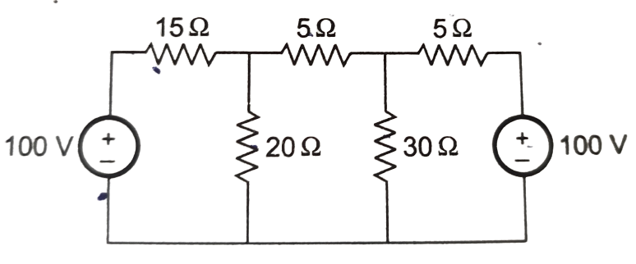 | L5 | CO1 | [5M]
 | b) | Calculate the effective resistance between points A and B in the given circuit.  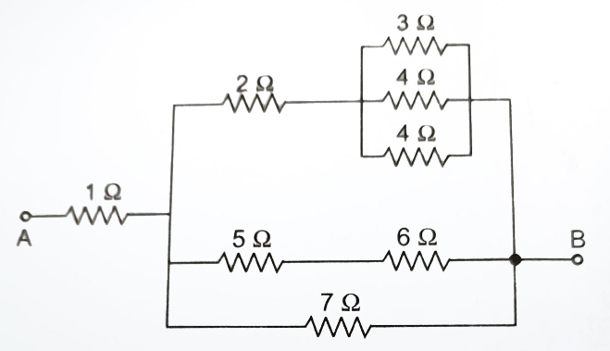 | L3 | CO1 | [5M]
12. | a) | Find the form factor for the following waveform  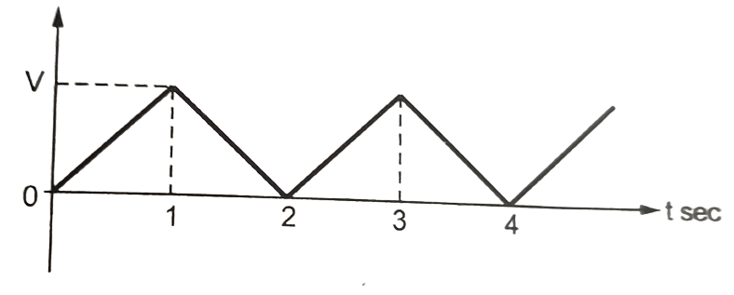 | L3 | CO2 | [5M]
 | b) | A series RLC circuit has R=10Ω, L=0.5H and C=40μF. The applied voltage is 100V. Find (a) Resonant frequency & Quality factor of a coil (b) Bandwidth | L3 | CO2 | [5M]
13. | a) | Derive the expression for co-efficient of coupling? | L5 | CO3 | [5M]
 | b) | Explain about dot convention in mutually coupled circuits. | L2 | CO3 | [5M]
14. | a) | Verify Superposition theorem for 4Ω resistor for the following circuit  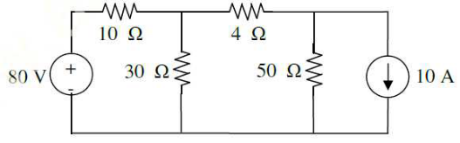 | L4 | CO4 | [5M]
 | b) | State the steps to solve the Thevenin’s Theorem | L1 | CO4 | [5M]
15. | a) | Find the Y- parameters for the following circuit.  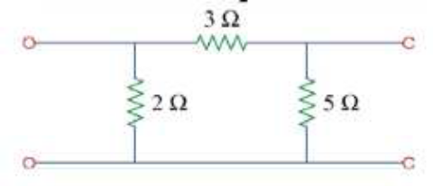 | L3 | CO5 | [5M]
 | b) | Derive the condition of symmetry for Z-parameters. | L5 | CO5 | [5M]
16. | a) | Derive expression for transient response of series R-L circuit driven by DC excitation by using differential equation method? | L5 | CO6 | [5M]
 | b) | The switch is moved from position 1 to 2 at t=0. Find the voltages V_{R}(t) and V_{C}(t) for t≥0.  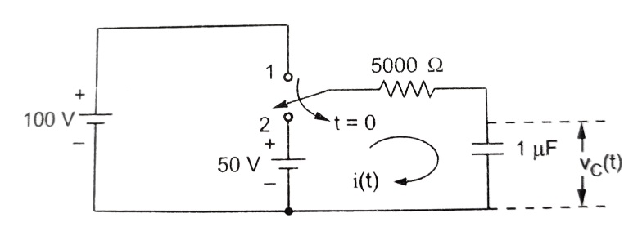 | L3 | CO6 | [5M]
17. | a) | State and explain Kirchhoff’s laws? | L1 | CO1 | [4M]
 | b) | Define Average value and RMS value of an alternating quantity? | L1 | CO2 | [3M]
 | c) | Explain the Faraday’s laws of electromagnetic induction? | L6 | CO3 | [3M]
18. | a) | State and explain Norton’s theorem? | L1 | CO4 | [4M]
 | b) | Express Z parameters in terms of ABCD parameters. | L3 | CO5 | [3M]
 | c) | Explain under damped response of series RLC circuit for DC excitation? | L6 | CO6 | [3M]

-- 00 -- 00 –

